Ecommerce Sales Performance Analysis – Project Report
Author: B Aiesha
Tools Used: Python | SQL | Power BI

1. Project Overview
The objective of this project is to perform an end-to-end analysis of ecommerce sales data to understand revenue trends, customer behaviour, category performance, and payment preferences.
This project demonstrates the complete data analytics lifecycle starting from raw data loading and cleaning using Python, analytical querying using SQL, and interactive dashboard creation using Power BI to generate actionable business insights.

2. Dataset Summary
• Total Records (Rows): [e.g., 50,000]
• Total Features (Columns): [e.g., 24]
• Data Format: Structured tabular data (CSV)
• Time Period Covered: [e.g., Jan 2022 – Dec 2024]
• Granularity: Product-level transactional data

The project is based on a simulated ecommerce dataset containing transactional, product, and customer-level information.
Dataset Characteristics:
- Raw dataset containing missing values, duplicates, and inconsistent formats
- Data structured into three final tables after cleaning
Final Tables:
- Orders Table: Order ID, Order Date, Quantity, Revenue, Payment Mode
- Products Table: Product ID, Category, Price, Rating
- Customers Table: Customer ID, City, Subscription Status

3. Data Loading Using Python
The raw ecommerce dataset was loaded into Python using the Pandas library for initial inspection and preprocessing.
- Imported CSV files into DataFrames
- Checked dataset shape, column names, and data types
- # Column Non-Null Count Dtype
- --- ------ -------------- -----
- 0 Order ID 50600 non-null int64
- 1 Order Date 50600 non-null object
- 2 Customer ID 50600 non-null int64
- 3 Product ID 50600 non-null int64
- 4 Category 50600 non-null object
- 5 City 48040 non-null object
- 6 Price 48576 non-null float64
- 7 Discount % 48105 non-null float64
- 8 Quantity 50600 non-null int64
- 9 Rating 48576 non-null float64
- 10 Payment Mode 48032 non-null object
- 11 Subscription Status 45474 non-null object
- dtypes: float64(3), int64(4), object(5)
- memory usage: 4.6+ MB

4. Data Cleaning & Preparation (Python)
Data cleaning was performed to ensure data accuracy and consistency before analysis.
Cleaning Steps Performed:
- Removed duplicate records from the dataset
- Handled missing values in revenue, rating, and category fields
- Converted date columns into proper datetime format
- Standardized category and payment mode values
- Renamed columns for consistency and readability
- Feature engineering to get revenue column

- Index: 50090 entries, 0 to 50593
- Data columns (total 18 columns):
- # Column Non-Null Count Dtype
- --- ------ -------------- -----
- 0 order_id 50090 non-null int64
- 1 order_date 50090 non-null datetime64[ns]
- 2 customer_id 50090 non-null int64
- 3 product_id 50090 non-null int64
- 4 category 50090 non-null object
- 5 city 50090 non-null object
- 6 price 50090 non-null float64
- 7 discount_% 50090 non-null float64
- 8 quantity 50090 non-null int64
- 9 rating 50090 non-null float64
- 10 payment_mode 50090 non-null object
- 11 subscription_status 50090 non-null object
- 12 discounted_price 50090 non-null float64
- 13 revenue 50090 non-null float64
- 14 order_year 50090 non-null int32
- 15 order_month 50090 non-null int32
- 16 order_quarter 50090 non-null object
- 17 month_name 50090 non-null object
- dtypes: datetime64[ns](1), float64(5), int32(2), int64(4), object(6)
- memory usage: 6.9+ MB

5. Exploratory Data Analysis (EDA)
Exploratory Data Analysis was conducted using Python to understand data distribution and identify patterns.
EDA Highlights:
- Analyzed revenue distribution across categories
- Identified top-performing cities based on sales
- Checked customer subscription impact on revenue
- Verified rating distribution across product categories
The EDA process helped validate data quality and guided further SQL and dashboard analysis.

6. SQL Analysis
After cleaning, the structured data was loaded into a SQL database for analytical querying.
Business Questions Answered Using SQL:
1) .... Count number of customers with active subscription
SELECT COUNT(*) AS subscribed_customers
FROM customers
WHERE subscription_status = 'Yes';
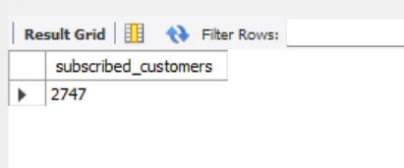

2) ..... which product category is performing good?
SELECT p.category,round(SUM(o.revenue),2) AS total_revenue
FROM orders o
JOIN products p ON o.product_id = p.product_id
GROUP BY p.category
Order by round(SUM(o.revenue),2) desc;

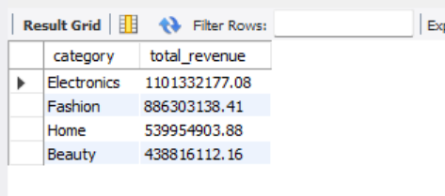
-- 3) which city is performing well and which city is underperformed ?
SELECT c.city, round(SUM(o.revenue),2) AS total_sales
FROM orders o
JOIN customers c ON o.customer_id = c.customer_id
GROUP BY c.city
Order by round(SUM(o.revenue),2) desc;
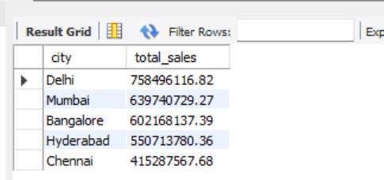
- 4) .... Highest Spending Customer
- SELECT o.customer_id,c.city,round(SUM(o.revenue),2) AS total_spent
- FROM orders o JOIN customers c ON o.customer_id = c.customer_id
- GROUP BY o.customer_id, c.city
- ORDER BY total_spent DESC
- LIMIT 1;
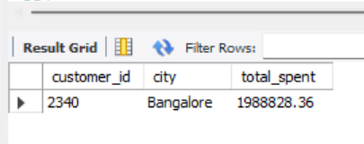

-- 5) .... Orders paid using each payment mode
SELECT payment_mode,COUNT(*) AS total_orders
FROM customers c
JOIN orders o ON c.customer_id = o.customer_id
GROUP BY payment_mode;
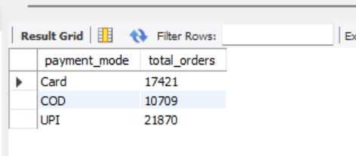

7. Power BI Dashboard
Power BI was used to build an interactive dashboard to visually represent insights derived from the analysis.
Dashboard Features:
- KPI cards for Total Revenue, Total Orders, and Average Rating
- Monthly revenue trend analysis by category
- Category-wise and city-wise revenue comparison
- Payment mode distribution analysis
- Interactive slicers for Date, Category
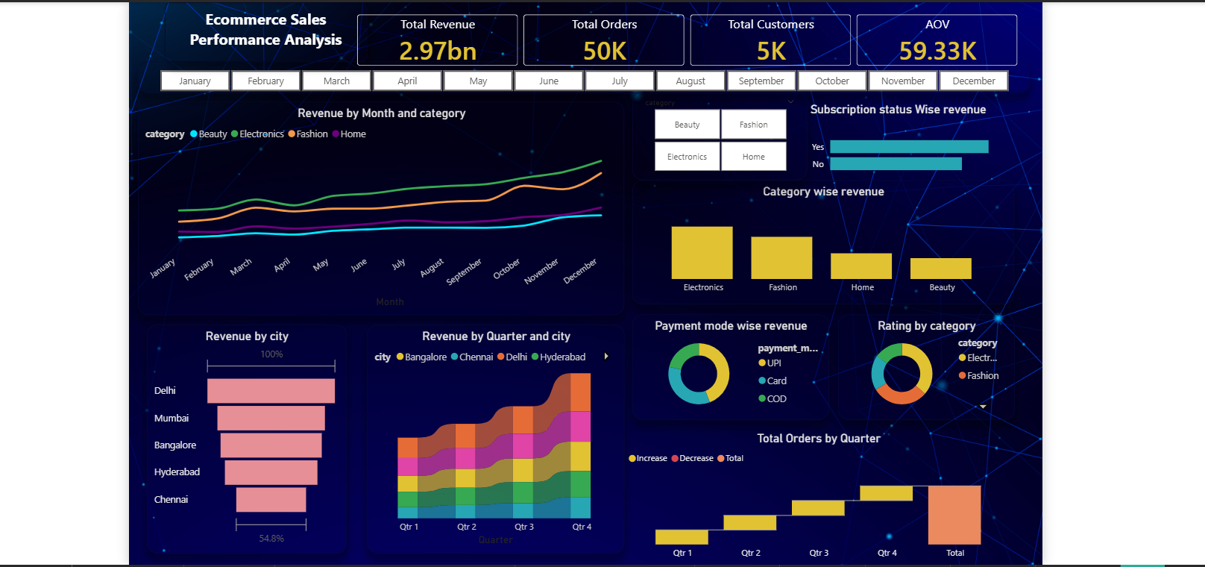

8. Key Insights
- Electronics is the highest revenue-generating category across all time periods
- Revenue shows an upward trend with peak performance during Q4
- Subscribed customers contribute significantly higher revenue
- Metro cities such as Delhi and Mumbai are the top revenue contributors
- UPI is the most commonly used payment method
- Electronics and Fashion categories receive higher customer ratings

9. Business Recommendations
- Focus marketing and inventory strategies on high-performing categories like Electronics and Fashion
- Strengthen subscription-based offers to increase customer retention
- Target promotional campaigns in top-performing cities
- Encourage digital payment methods through offers and discounts
- Improve underperforming categories by analyzing customer feedback

10. Conclusion
This project showcases a complete data analytics workflow using Python, SQL, and Power BI. By transforming raw ecommerce data into meaningful insights, the project demonstrates strong analytical, technical, and business-oriented skills relevant to real-world data analyst roles.

